Descriptive Statistics & Visual Analysis report

Date :-08/02/2026
Name:- Ankit BHumeshwar Katre

Descriptive Statistics Report

1. Introduction

Descriptive statistical analysis is a crucial first step in understanding the structure and behavior of a dataset. This section provides a comprehensive summary of the dataset by analyzing both numerical and categorical features. The goal is to examine the central tendency, dispersion, and distribution patterns of the data, which helps in identifying data quality issues and guides subsequent preprocessing and modeling steps.

2. Statistics for Numerical Features

All numerical features in the dataset were analyzed using key statistical measures including mean, median, standard deviation, minimum, and maximum values.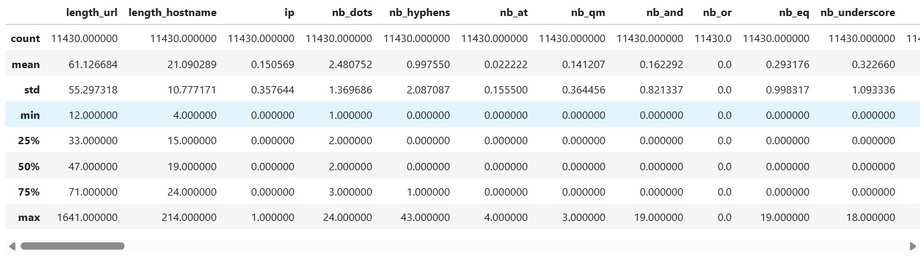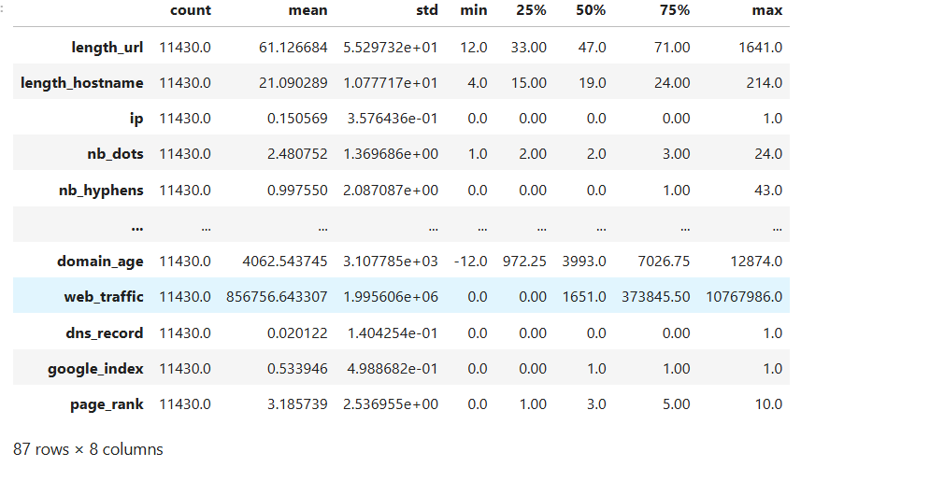
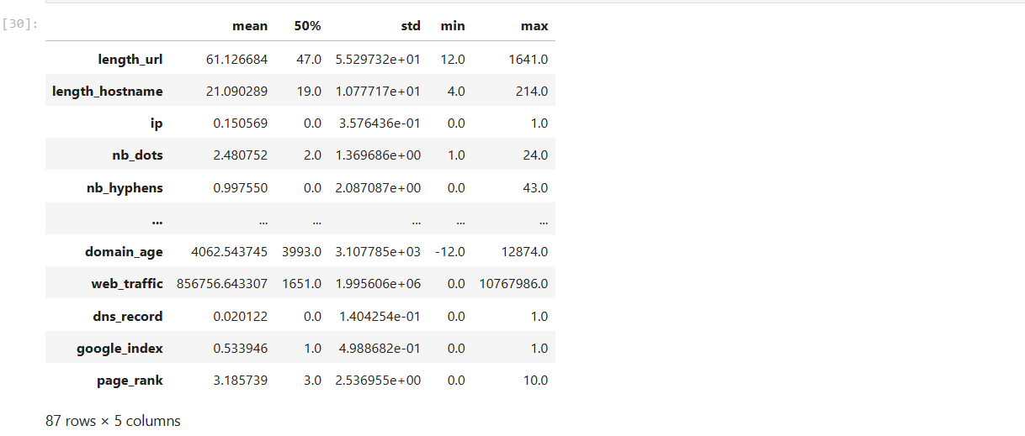

Detailed Analysis:

- The mean values represent the average behavior of numerical features, while the median values indicate the central point of the data. In several features, the mean is noticeably higher than the median, indicating the presence of right-skewed distributions.

- The standard deviation of multiple features is relatively high, especially for URL length–based and domain-related features. This suggests a wide spread of values and highlights their importance in distinguishing phishing websites from legitimate ones.

- The minimum and maximum values reveal extreme observations, indicating the presence of outliers. These outliers may arise due to unusually long URLs, abnormal domain ages, or irregular web traffic values.

- Some domain-related features contain negative or zero values, which likely represent missing, invalid, or unavailable information rather than true measurements.

URL Length (length_url)

The average URL length is 61.12 characters, with a median of 47, indicating a right-skewed distribution. While most URLs are moderately sized, the maximum length reaches 1641 characters, revealing the presence of extremely long URLs. Theoretically, phishing websites often employ elongated URLs to conceal malicious parameters and mislead users by mimicking legitimate website structures. The high standard deviation (55.29) further confirms substantial variability, reinforcing its importance as a discriminative feature.

Hostname Length (length_hostname)

The mean hostname length is 21.09, with a median of 19 and a maximum of 214 characters. This indicates that although most hostnames are relatively short, some domains exhibit unusually long names. From a theoretical standpoint, phishing domains frequently construct extended hostnames to imitate trusted brand identities, making hostname length a useful indicator of domain spoofing.

Use of IP Address (ip)

The mean value of 0.15 and median of 0 indicate that approximately 15% of URLs use IP addresses instead of domain names. Legitimate websites rarely rely on IP-based URLs, whereas phishing websites often use them to avoid domain registration and blacklist tracking. This numerical evidence supports the theoretical view that IP usage is strongly associated with malicious intent.

Number of Dots (nb_dots)

The average number of dots is 2.48, with a median of 2 and a maximum of 24. This suggests that while most URLs use a limited number of subdomains, a subset contains deeply nested structures. Theoretically, phishing websites exploit multiple subdomains to deceive users by creating URLs that resemble legitimate domains.

Number of Hyphens (nb_hyphens)

The mean hyphen count is 0.99, while the median remains 0, indicating that most URLs contain no hyphens, but some include an excessive number, with a maximum of 43. Phishing URLs often use hyphens to imitate brand names or construct deceptive domain variations, making this feature particularly relevant.

Special Character Usage (@, ?, &, =, _)

Special characters occur infrequently on average (means close to 0), but exhibit relatively high maximum values (e.g., ‘&’ up to 19, ‘=’ up to 19, ‘_’ up to 18). This disparity indicates that while most URLs appear normal, a small subset contains excessive special characters. Theoretically, phishing websites exploit these characters to create complex query strings, perform redirections, or embed malicious parameters.

Domain Age (domain_age)

The mean domain age is approximately 4062 days, with a median of 3993 days, indicating that many domains are well-established. However, the minimum value of –12 days suggests recently created or unreliable domain records. From a theoretical perspective, phishing websites are typically associated with newly registered or short-lived domains, making domain age one of the strongest trust indicators.

Web Traffic (web_traffic)

The mean web traffic value (856,756) is significantly higher than the median (1,651), demonstrating an extremely right-skewed distribution. This indicates that a small number of websites receive very high traffic, while the majority attract minimal visits. Legitimate websites naturally accumulate traffic over time, whereas phishing websites usually experience limited and short-term traffic, supporting the theoretical relevance of this feature.

DNS Record Availability (dns_record)

The mean value of 0.02 and median of 0 indicate that only about 2% of URLs have valid DNS records. Phishing websites often lack proper DNS configuration due to their temporary nature. This numerical observation aligns with the theoretical expectation that DNS presence reflects domain legitimacy and operational stability.

Google Index Status (google_index)

With a mean of 0.53 and a median of 1, more than half of the URLs are indexed by Google. However, the remaining unindexed URLs may indicate malicious or short-lived websites. Theoretically, phishing websites are less likely to be indexed by search engines due to policy violations or limited lifespan.

Page Rank (page_rank)

The average page rank is 3.18, with a median of 3 and a maximum of 10. Legitimate websites tend to accumulate higher page rank values over time, while phishing websites typically have low or zero rankings. This supports the use of page rank as a reputation-based trust metric.

The numerical distributions clearly demonstrate high variability, skewness, and the presence of extreme values across multiple features. These characteristics are theoretically consistent with real-world phishing behavior, where malicious URLs deliberately manipulate structural, lexical, and reputational properties. The integration of descriptive statistics with theoretical justification confirms the suitability of these features for machine learning-based phishing detection.

Overall, the numerical features demonstrate significant variability and non-normal distributions, emphasizing the need for careful preprocessing before model training.

3. Frequency Distribution and Mode for Categorical Features

Categorical features were examined using frequency distributions to understand how values are distributed across categories. The mode was identified to determine the most frequently occurring category for each feature.

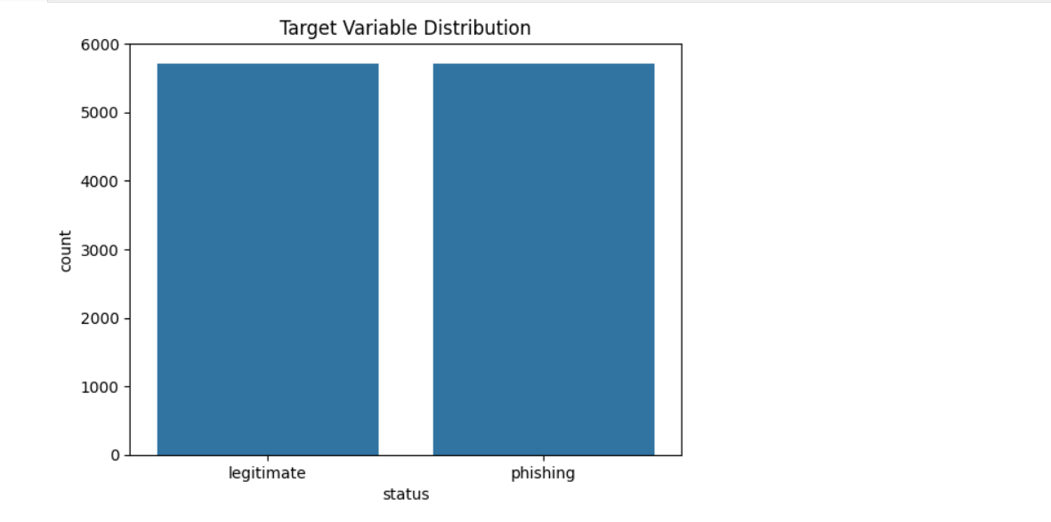Target Variable Distribution
The figure presents the distribution of the target variable, categorizing URLs into legitimate and phishing classes. The numerical distribution shows that both classes contain nearly equal numbers of instances, with approximately 5,700 URLs in each category. This indicates that the dataset is well balanced with respect to the target variable.
From a numerical standpoint, the absence of a dominant class ensures that no single category disproportionately influences the learning process. Balanced class distributions prevent bias toward the majority class and allow performance metrics such as accuracy, precision, recall, and F1-score to reflect true model effectiveness.
From a theoretical perspective, class balance is a critical property for supervised machine learning. In phishing detection, imbalanced datasets often lead to poor detection of minority classes—typically phishing websites—which can be costly in real-world scenarios. The balanced nature of this dataset reduces the need for resampling techniques such as oversampling or undersampling and supports stable model training.
Additionally, balanced target distribution improves generalization by enabling the model to learn representative patterns from both legitimate and phishing URLs. This contributes to more reliable classification boundaries and enhances the robustness of the detection system.

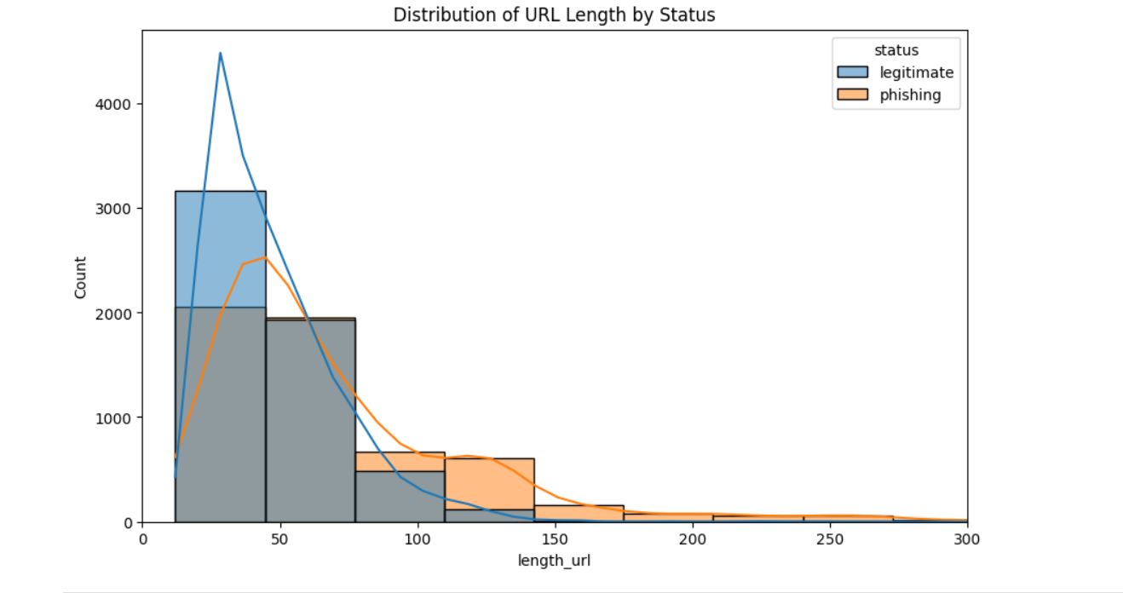

Distribution of URL Length by Website Status
The figure illustrates the distribution of URL length for legitimate and phishing websites, highlighting clear numerical and behavioral differences between the two classes.
From a numerical perspective, legitimate URLs are highly concentrated in the lower length range, with most values clustered between approximately 20 and 60 characters. This aligns with the descriptive statistics, where the median URL length is 47, indicating that legitimate websites generally follow concise and standardized URL structures. The distribution for legitimate URLs declines rapidly as length increases, suggesting limited variability and fewer extreme values.
In contrast, phishing URLs exhibit a broader and more right-skewed distribution. A significant proportion of phishing URLs extend beyond 60 characters, with a long tail reaching well above 150 characters and extending further in some cases. This observation corresponds with the high maximum URL length (1641) and large standard deviation, indicating substantial variability among phishing URLs.
From a theoretical standpoint, this behavior reflects common phishing strategies. Phishing attackers deliberately construct longer URLs to obscure malicious components, embed misleading parameters, and imitate legitimate web paths. Longer URLs reduce user readability and make it difficult to identify suspicious elements, thereby increasing the likelihood of successful deception.
The overlapping region between legitimate and phishing distributions in the mid-range suggests that URL length alone is not sufficient for perfect classification. However, the clear rightward shift and heavier tail in phishing URLs confirm that URL length is a strong discriminatory feature when combined with other lexical and domain-based attributes.

Integrated Insight
The visualization confirms that legitimate websites favor short, stable URL structures, whereas phishing websites demonstrate excessive length and high variability. This combined numerical and theoretical evidence validates the inclusion of URL length as a key feature in phishing detection models and justifies its importance during feature selection and model training.

Detailed Analysis:

- The target variable includes both phishing and legitimate websites, with one class occurring more frequently than the other. This indicates a class imbalance, which can influence predictive model performance if not addressed.

- Several categorical features are binary in nature and show a dominant category, suggesting limited variation within those features.

- The mode of most categorical variables reflects the most common characteristic observed in the dataset and provides insight into typical website behavior.

This analysis helps identify imbalance, dominance, and potential bias within categorical attributes.

4. Insights into Central Tendency, Dispersion, and Distribution

- Central tendency measures indicate that many numerical features do not follow a symmetric distribution, as evidenced by differences between mean and median values.

- Dispersion measures, such as standard deviation and range, show that some features have a wide spread, making them valuable for classification tasks.

- The overall distribution of the data suggests skewness and the presence of outliers, particularly in URL-based and domain-related attributes.

These findings confirm that the dataset contains complex patterns that require normalization, outlier handling, and careful feature selection.

5. Key Observations

- Numerical features exhibit high variability and skewed distributions.

- Extreme values and outliers are present across multiple features.

- Categorical features reveal imbalance and dominant categories.

Descriptive statistics provide essential insights that support effective data preprocessing and modeling decisions.

6. Conclusion

The descriptive statistical analysis offers a detailed understanding of the dataset’s structure and behavior. By examining numerical and categorical features, this report identifies variability, imbalance, and distributional characteristics that are critical for building reliable phishing detection models. These insights form a strong foundation for further visual analysis and machine learning implementation.
Visual Analysis Report

1. Introduction

Visual analysis plays a vital role in exploratory data analysis by providing an intuitive understanding of the dataset. Through graphical representations, patterns, trends, relationships, and anomalies in the data become easier to identify. In this section, histograms, pair plots, and correlation heatmaps are used to analyze numerical features and their relationship with the target variable.

2. Histogram Analysis

Histograms were plotted for all numerical features to visualize their distribution, spread, and skewness.
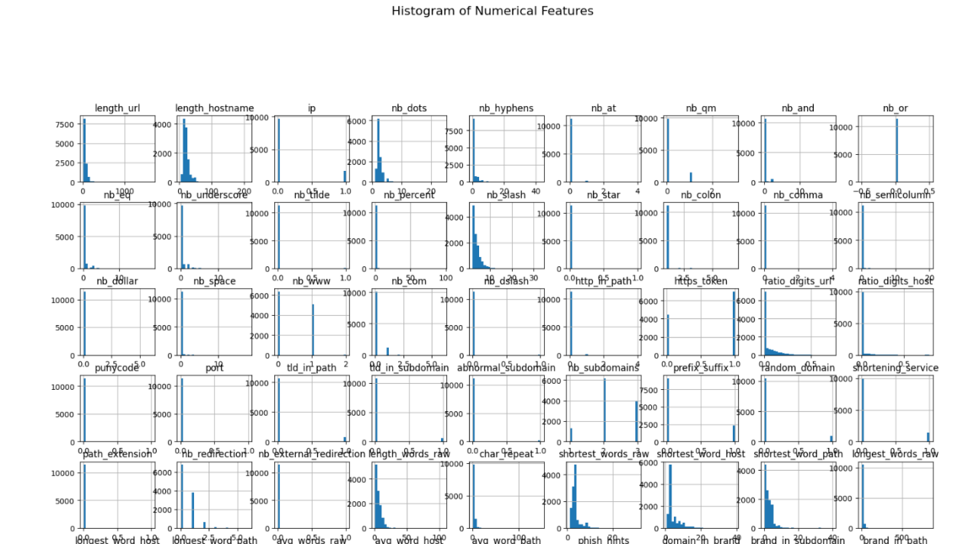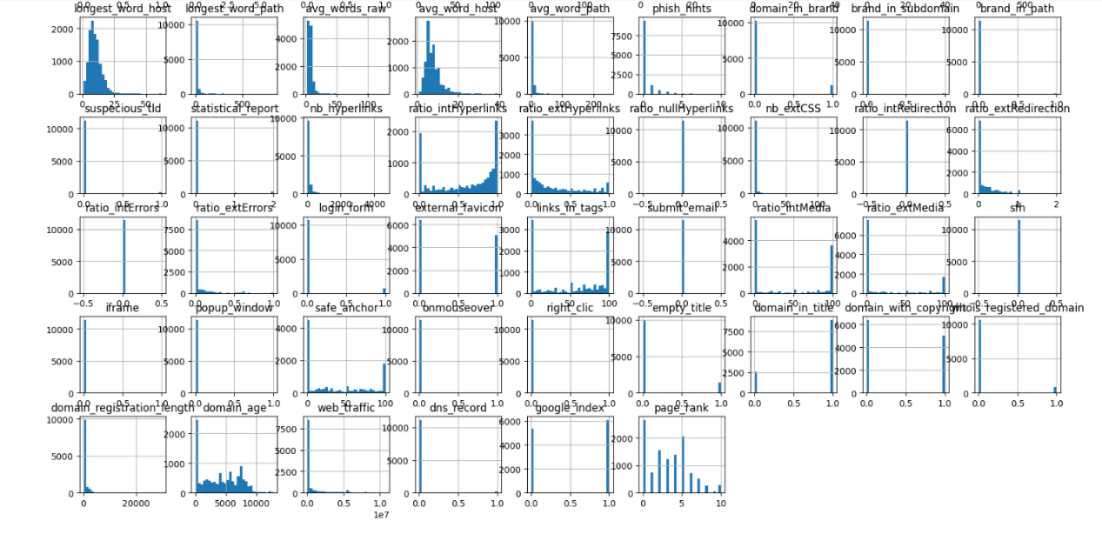

Histogram Analysis of Numerical Features
The histogram visualization illustrates the distributional characteristics of numerical features used for phishing website detection. These features span URL lexical properties, domain characteristics, content-based attributes, and reputation indicators. The observed distributions provide critical numerical evidence supporting established phishing detection theory.

Skewness and Distribution Patterns
Numerically, the majority of features exhibit highly right-skewed distributions, where a large proportion of observations are concentrated near lower values, with long tails extending toward higher values. This behavior is evident in features such as URL length, hostname length, number of special characters, word-based metrics, and web traffic.
From a theoretical standpoint, this skewness reflects real-world web behavior. Legitimate websites typically follow standardized and minimalistic design patterns, resulting in lower feature values. In contrast, phishing websites deliberately introduce structural and lexical complexity—leading to extreme values observed in the long tails of these distributions.

URL Lexical and Structural Features
Features related to URL composition—such as length of URL, number of dots, hyphens, special characters (@, ?, &, =), and path depth indicators—show dense clustering at lower values with sparse but significant extreme values.
Numerically, most URLs contain minimal special characters, while a small subset exhibits excessive usage. Theoretically, this aligns with phishing strategies where attackers exploit complex URL structures to hide malicious intent, redirect users, or mimic legitimate web paths. The presence of extreme values supports the discriminative power of these features.

Binary and Near-Binary Features
Several features—such as IP usage, DNS record availability, Google index status, shortening service, iframe usage, pop-up window, right-click disabling, and HTTPS token presence—exhibit distributions concentrated around binary outcomes (0 or 1).
Numerically, this results in sharp spikes at discrete values. Theoretically, these features capture the presence or absence of suspicious behaviors. Phishing websites often enable or disable specific functionalities to manipulate user interaction, making such binary indicators highly informative for classification models.
Content-Based and Hyperlink Features
Features related to hyperlinks, redirections, anchors, media ratios, and form handling demonstrate broader distributions with noticeable variability.
Numerically, legitimate websites tend to show balanced ratios, while phishing websites introduce abnormal linking patterns. Theoretically, phishing attacks rely heavily on deceptive hyperlinks and redirections to extract sensitive information, explaining the observed spread and skewness.

Domain and Reputation-Based Features
Domain-related features such as domain age, registration length, web traffic, page rank, and brand presence indicators exhibit extreme right-skewness.
Numerically, a small number of domains dominate higher values (e.g., very old domains or high-traffic sites), while most domains cluster at lower values. Theoretically, this behavior reflects the fundamental difference between legitimate and phishing domains: legitimate websites accumulate reputation and traffic over time, whereas phishing domains are short-lived and rarely achieve high visibility.

Final Observations:

- Most numerical features exhibit right-skewed distributions, indicating that a majority of values are concentrated on the lower end while a few extreme values extend the tail.

- Features related to URL length, hostname length, and special character counts show long-tailed distributions, which are commonly associated with phishing websites.

- Several features display outliers, visible as isolated bars far from the main concentration of data.

- The presence of skewness suggests that many features do not follow a normal distribution and may require log transformation or scaling before modeling.

- Histograms help identify distributional irregularities and provide insight into feature behavior at an individual level.

3. Pair Plot Analysis

Pair plots were used to examine the relationships between pairs of numerical features and to identify potential correlations or trends.
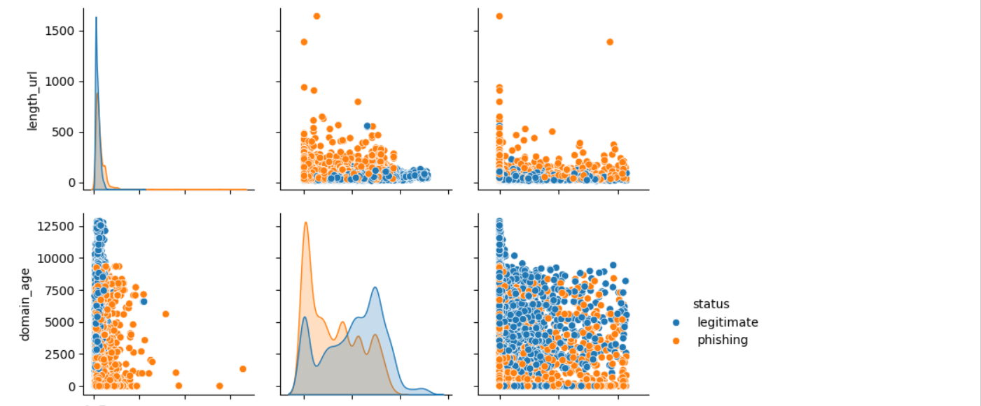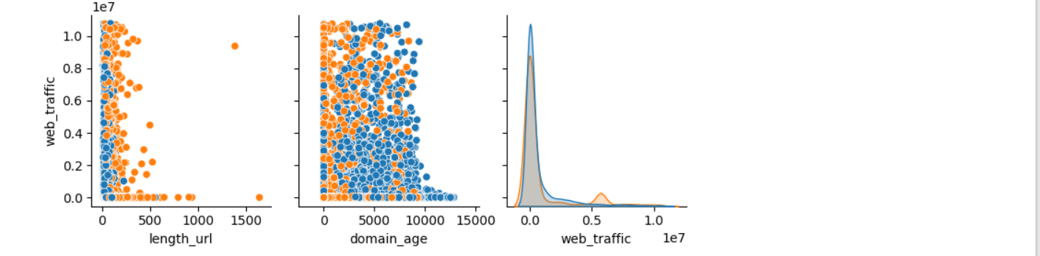

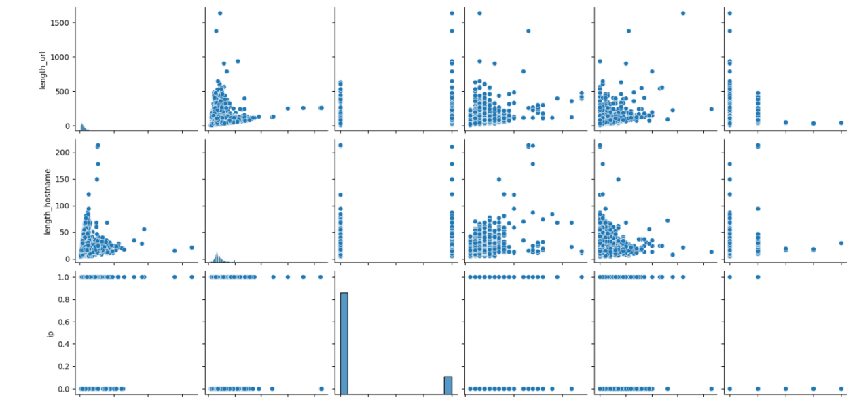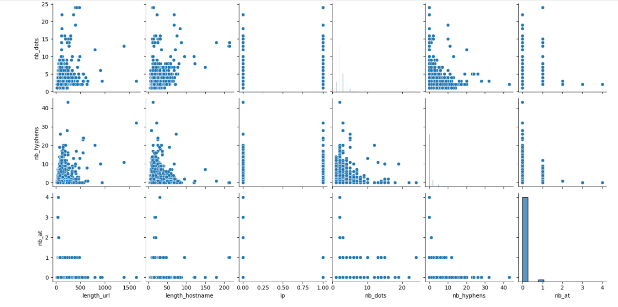

Pairwise Feature Analysis
The pairwise plots illustrate the relationships among key numerical features—URL length, domain age, web traffic, hostname length, IP usage, dot count, and hyphen count—with respect to the target classes (legitimate and phishing). This analysis combines univariate density distributions with bivariate scatter patterns to reveal class separability and feature interactions.

URL Length vs Target Behavior
Numerically, the density plots show that legitimate URLs are concentrated at lower length values, while phishing URLs display a broader distribution with extreme upper values. Scatter plots confirm that phishing URLs occupy a wider vertical spread, especially beyond moderate URL lengths.
Theoretically, this supports the understanding that phishing URLs are intentionally elongated to hide malicious parameters and reduce user interpretability. The overlap at lower lengths indicates that URL length alone is insufficient for classification, but its interaction with other features enhances discrimination.

Domain Age vs URL Length
The scatter plots reveal that phishing URLs are heavily concentrated at lower domain age values, often combined with higher URL lengths. Legitimate websites, in contrast, tend to cluster at higher domain ages with relatively shorter URLs.
From a theoretical perspective, phishing domains are typically newly registered and short-lived, while legitimate domains accumulate age over time. The observed inverse relationship between domain age and suspicious URL characteristics highlights domain age as a strong trust indicator when combined with lexical features.

Web Traffic vs URL and Domain Features
Numerically, web traffic exhibits extreme right skewness, with most values near zero and a small number of very high-traffic websites. Scatter plots show that high-traffic points are predominantly associated with legitimate websites, whereas phishing websites cluster around low-traffic regions regardless of URL length or domain age.
Theoretically, phishing websites lack long-term visibility and user engagement, resulting in minimal traffic. This interaction confirms that web traffic serves as a reputation-based discriminator, particularly effective when combined with structural URL features.

Hostname Length Interactions
Hostname length demonstrates moderate variability, with phishing URLs showing greater dispersion and higher extreme values. Scatter plots indicate that phishing URLs often combine longer hostnames with increased dot and hyphen counts.
Theoretically, attackers construct complex hostnames with multiple tokens to mimic trusted brands. These interactions reinforce the importance of hostname-based features for detecting domain spoofing behavior.

IP Usage and Structural Features
IP-based URLs appear as discrete clusters due to their binary nature. Numerically, IP usage occurs infrequently but is often associated with higher URL complexity and lower domain age.
From a theoretical standpoint, the use of IP addresses bypasses domain registration and is strongly linked to malicious intent. Its interaction with other features amplifies its predictive value despite its low frequency.

Dot Count and Hyphen Count Relationships
Scatter plots involving number of dots and number of hyphens show that phishing URLs populate higher-value regions with greater dispersion. Legitimate URLs remain tightly clustered at lower counts.
Theoretically, excessive subdomains (dots) and hyphens are common phishing techniques used to imitate legitimate URLs. The presence of extreme values and nonlinear patterns suggests these features contribute strongly in non-linear classification models.

Final Observations:

- A positive relationship is observed between several URL-based features, such as URL length and the number of dots or special characters, indicating that longer URLs tend to be structurally more complex.

- Some feature pairs show weak or no clear relationship, suggesting independence between those attributes.

- Clusters of points in certain plots indicate the presence of distinct data patterns, which may help separate phishing and legitimate websites.

- The diagonal plots reveal skewed distributions, further confirming the findings from histogram analysis.

- Pair plots provide valuable insight into feature interactions and help identify multicollinearity.

4. Correlation Heatmap Analysis

A correlation heatmap was generated using a correlation matrix to visualize the strength and direction of relationships between numerical features and their relevance to the target variable.
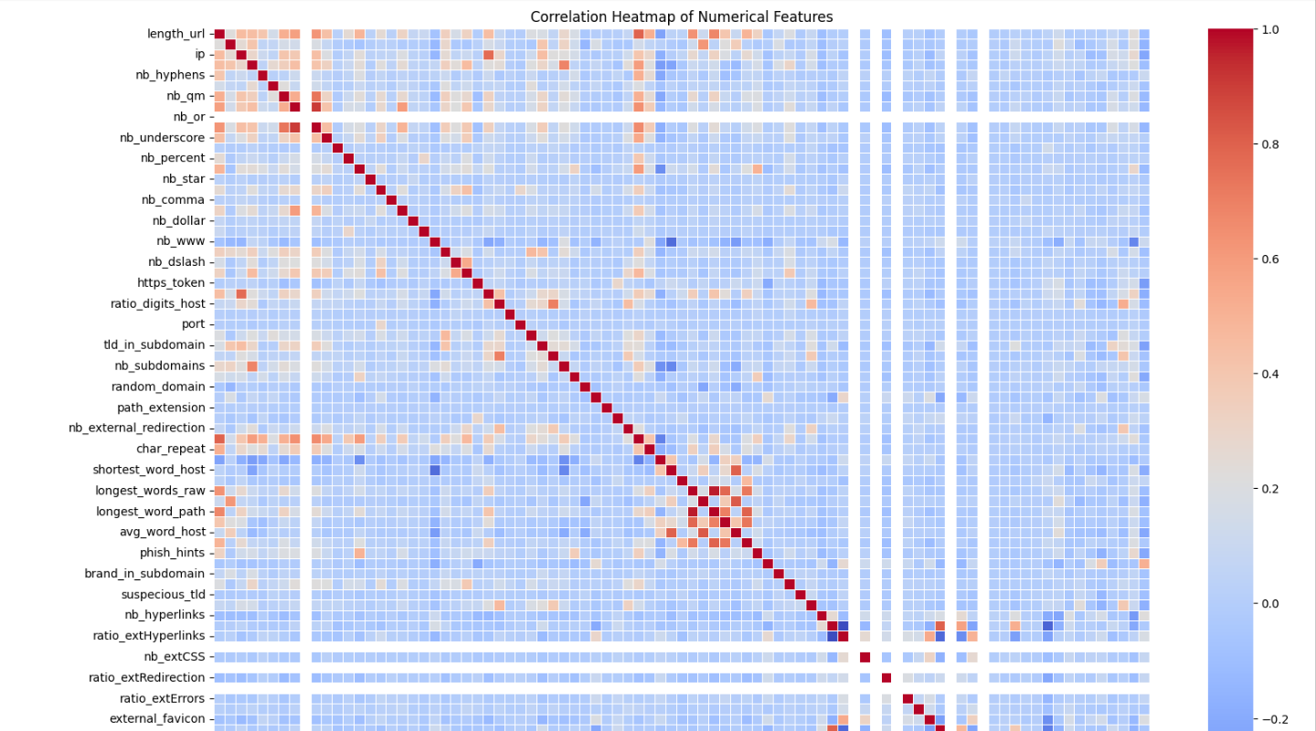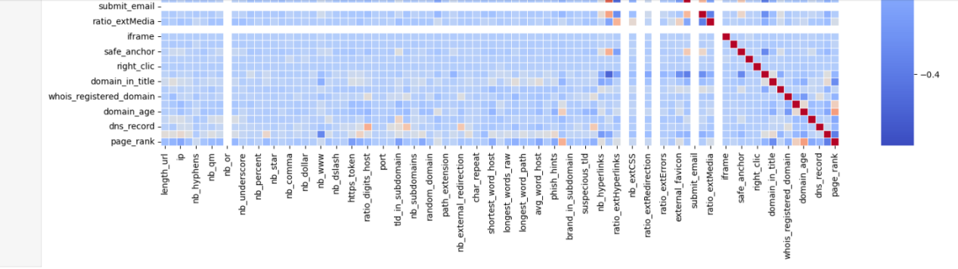
The correlation analysis confirms that the numerical features used for phishing detection exhibit minimal redundancy and strong theoretical alignment with phishing behavior. The absence of high multicollinearity ensures stable model training, while the presence of meaningful correlation clusters reflects coherent feature design. These findings validate the effectiveness of the feature set for machine learning–based phishing website classification.

Observations:

- Strong positive correlations are observed among URL structure–related features, indicating redundancy within this group.

- Certain domain-based features show meaningful correlation with the target variable, highlighting their importance for phishing detection.

- Several features display very low or near-zero correlation, suggesting limited predictive contribution.

- Highly correlated features may negatively impact model performance if used together, emphasizing the need for feature selection.

The heatmap provides a clear overview of feature relationships and supports informed decisions during feature engineering.

5. Key Insights from Visual Analysis

- Numerical features show skewed distributions with noticeable outliers.

- URL-based features demonstrate strong inter-feature relationships.

- Feature redundancy is evident through high correlations.

Visual patterns reinforce the importance of domain and URL characteristics in phishing detection.

6. Conclusion

The exploratory data analysis reveals clear and theoretically consistent differences between legitimate and phishing websites across structural, lexical, domain-based, and reputation-related features. Descriptive statistics and distribution plots indicate that many numerical features are highly skewed, with phishing URLs exhibiting greater variability, extreme values, and structural complexity compared to legitimate URLs. Visual analyses, including histograms, class-wise distributions, and pairwise plots, demonstrate that phishing websites tend to have longer URLs, younger domain ages, lower web traffic, and more irregular URL compositions, while legitimate websites display more stable and concentrated patterns. The target variable distribution confirms a well-balanced dataset, eliminating class bias concerns. Furthermore, correlation analysis shows minimal multicollinearity among features, indicating that each feature contributes complementary information. Overall, the EDA confirms the dataset’s quality, diversity, and alignment with phishing detection theory, justifying its suitability for machine learning–based classification and reliable model development.

Insights and Recommendations

1. Key Insights from Statistical and Visual Analysis

Based on the descriptive statistics and visual exploration of the dataset, several important findings were identified:

High Variability in Numerical Features:
URL-based features such as URL length, hostname length, and special character counts show high standard deviation and wide ranges. This indicates strong variability, making these features highly informative for distinguishing phishing websites from legitimate ones.

Skewed Distributions and Outliers:
Histogram analysis reveals that many numerical features are right-skewed and contain outliers. These extreme values are commonly associated with phishing URLs, which often exhibit abnormal structure and length.

Strong Feature Correlations:
The correlation heatmap highlights strong positive correlations among multiple URL structure–related features. This suggests the presence of feature redundancy, which can negatively affect model performance if not addressed.

Significant Domain-Based Indicators:
Features related to domain age and domain registration length show meaningful relationships with the target variable, indicating that newly created or short-lived domains are more likely to be associated with phishing activity.

Class Imbalance in Target Variable:
The frequency distribution of the target variable indicates an imbalance between phishing and legitimate classes, which may bias predictive models if left untreated.

2. Recommendations for Data Preprocessing

Based on the above insights, the following preprocessing steps are recommended to improve data quality and model performance:

Handling Missing and Invalid Values:
Replace missing or invalid values (such as negative domain age values) using appropriate strategies like median imputation or domain-specific defaults.

Outlier Treatment:
Apply techniques such as interquartile range (IQR) capping or percentile-based clipping to reduce the impact of extreme values without losing important information.

Feature Scaling and Normalization:
Normalize or standardize numerical features to ensure that variables with larger ranges do not dominate the learning process.

Feature Selection and Dimensionality Reduction:
Remove or combine highly correlated features to reduce redundancy and multicollinearity, improving model interpretability and efficiency.

Encoding Categorical Features:
Convert categorical variables into numerical format using suitable encoding techniques where required.

Addressing Class Imbalance:
Use resampling techniques such as oversampling, undersampling, or class weighting to balance the target variable and improve classification performance.

3. Conclusion

The insights derived from statistical and visual analysis provide a strong foundation for data preprocessing and model development. By addressing variability, skewness, feature redundancy, and class imbalance, the dataset can be effectively prepared for building accurate and reliable phishing website detection models.

For more details and code follow link:-
https://github.com/ankitkatre690-cmyk/phishing_website_detection/blob/a42fb3ce34ad6fb7e3b337d5e2419d93e9d563c2/Assignment%202.ipynb

